Health & Well-being as Professional Learning (Using the Professional Learning Cycle Model to support PRD)
A commitment to reflecting on the connections between values and actions and career-long professional learning is a critical part of developing teacher professionalism. Critical self-evaluation is therefore an important part of professional learning and the PRD process. This includes asking deep and searching questions about self and practice as well as considering the needs of learners/colleagues in your context.
Self-evaluation - The General Teaching Council for Scotland (gtcs.org.uk)

In what follows the Professional Learning Cycle Model and the GTCS Self-Evaluation Wheel are used to support self-evaluation processes, prompt thinking and ask questions.

Self Evaluation Wheel – Standard for Career-Long Professional Learning
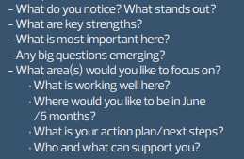
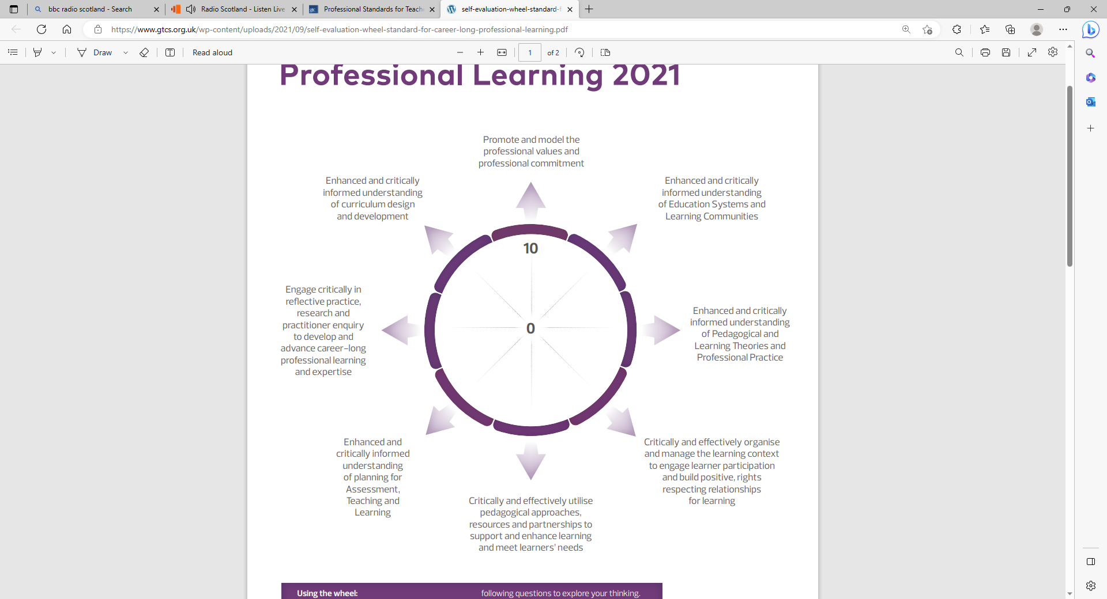
X
X
X
X
X
X
X
X
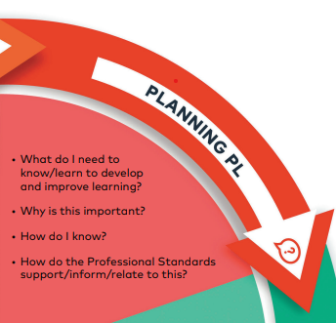
- Where am I at now? What are my strengths and weaknesses?
What do I want to Improve?
At times in the school week and school year I often feel tired, stressed and unhappy. This means that sometimes I can’t think clearly and I feel that I can’t cope. I feel that this affects my ability to teach with energy and innovation, as well as reflect upon my practice with the purpose of improvement.
I want to improve my own mental health-wellbeing and develop my ability to reflect calmly on my own practice.

- Why is it important?
I don’t just want to cope. I want to develop strategies to support my teaching practice, the learning of my pupils and the relationships I have with my pupils and colleagues.

- How do the Professional Standards relate to this?
The GTCS Standard 1.1 Professional Values (see below) makes clear how including an aspect of H&WB as an area for development is both legitimate in terms of being able to evaluate against GTCS Standards and developing the professional values that are at the core of ‘what it means to be a teacher in Scotland’.

  - Professional Values
Social Justice. Social justice is the view that everyone deserves equal economic, political and social rights and opportunities now and in the future.
- Promoting health and wellbeing of self, colleagues and the children and young people in my care.
Trust and Respect. Trust and respect are expectations of positive actions that support authentic relationship building and show care for the needs and feelings of the people involved and respect for our natural world and its limited resources.

- Understanding health and wellbeing and the importance of positive and purposeful relationships to provide and ensure a safe and secure environment for all learners and colleagues within a caring and compassionate ethos.

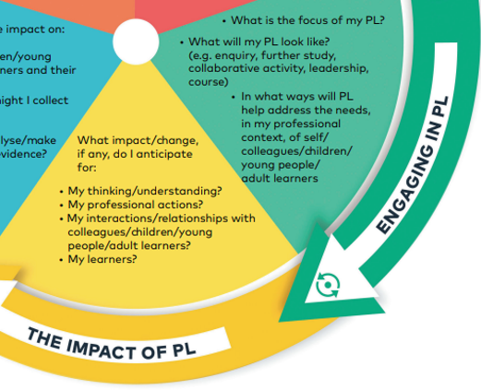
- What do I need to know/learn to develop and improve learning: What will my PL look like?
Participation on the ‘Lessons in Happiness’ course. The ‘Lessons in Happiness’ course is about how the mind works, how our thinking affects the way we perform and most importantly, how we can influence the whole process in a positive, effective way to achieve what we want….. and to be happier at the same time.

John Lamont, the author and presenter of our course, has a wealth of experience from the worlds of research, engineering, corporate management, therapy, coaching, motivation and teaching which all come together in the presentation.

The rationale for our course includes:

- Improving the quality of life and well-being of participants and of those around them;
- Developing and realising potential by empowering members with a simple, practical skill set,
By providing a ‘toolbox’ of mind-tools, supported by evidence-based scientific research.

(See details at the back of this document for further details and an EIS evaluation of the course)
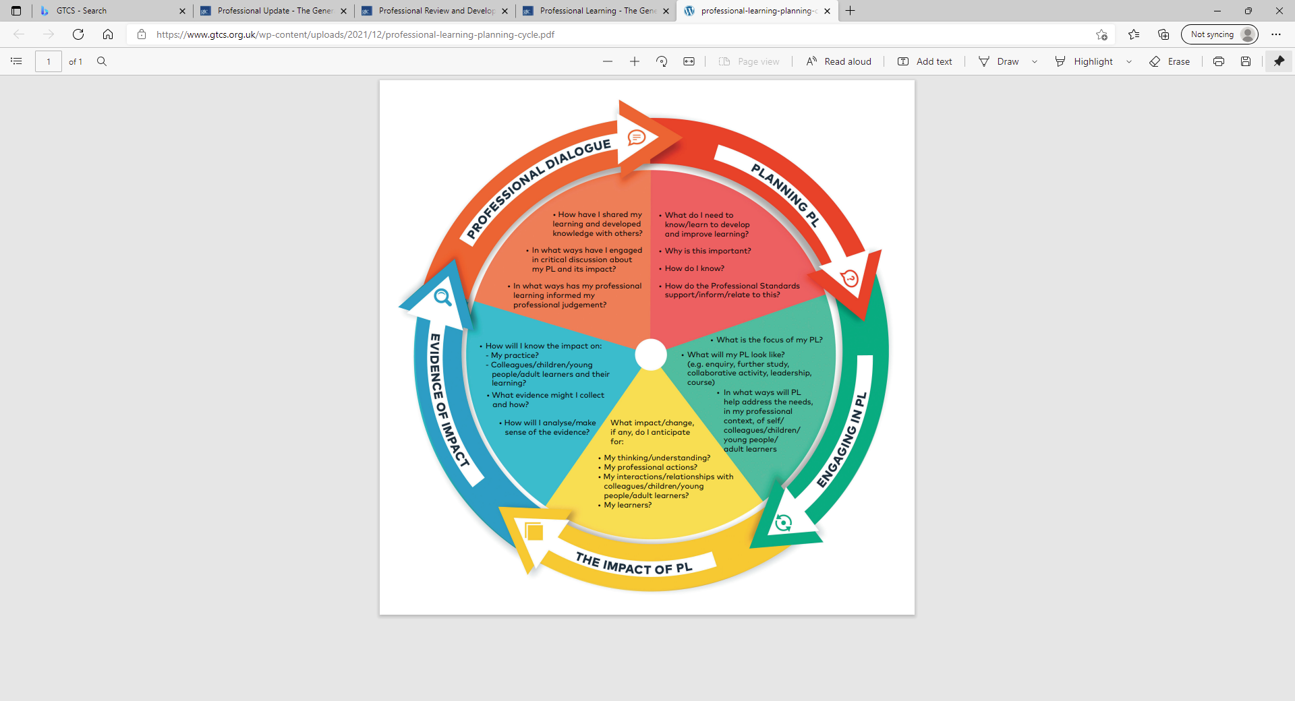
- The Impact of my Professional Learning?
(Some Suggestions – not a prescriptive list)
How will I know the impact on:
My practice? personal reflections – how well have I enacted 1.1 Professional Values in my daily practice?
My students and their learning? Pupil voice evaluations, teacher observation
The learning of my colleagues? discussions with colleagues
What evidence might I collect and how will I make sense of it? Personal reflections, journal entries, feedback from pupils and colleagues
(Update CEC Professional Learning Profile periodically to reflect thoughts arising from any of the above)
- Professional Dialogue
PRD provides teachers with ongoing opportunities to reflect on their practice and personal learning through professional learning conversations throughout the year…
and supported by an annual review meeting.

            - Discussions with colleagues, contribution to Whole School Improvement plan and School Improvement Groups

            - Personal reflections and discussions with colleagues.

            - Enacting 1.1 Professional Values through my daily practice

            - (For the brave!) Potential to undertake 360 feedback technique to gain professional and honest performance reviews (from colleagues and pupils).
What is 360 feedback? (with examples, benefits and FAQs) | Indeed.com UK

- How now can my use of the Professional Learning Cycle Model be written up in my Professional Learning Profile?
Please see over which provides an example of how the process described above can be captured within the Professional Learning Profile.

Appendix 4: Professional Learning Profile (optional)

PLAN: SELF-EVALUATION |  | PLAN: IDENTIFY AREA OF DEVELOPMENT |  |  |  | EVALUATE
Self-Evaluation |  | Description of PL | Target date | Intended impact | Link to standard | Reflection & Impact
What knowledge & skills do our students/colleagues/community need? Where are they now? What is the goal? What is the issue? How do we know? | What do I need to know/learn to develop & improve my students and/or colleagues learning? | What is the focus of my PL? What will it look like? |  | How will I know the impact on a) my practice b) my students’ learning c) my colleagues? | How do the Professional Standards support/inform/relate to this? | What has been the impact of my Professional Learning on my students /colleagues?  This should feed directly into your learning priorities for the following year (column 1)
I want to improve my own mental health-wellbeing and develop my ability to reflect calmly on my own practice and be happier in my role.  At times in the school week and school year I often feel tired, stressed and unhappy. This means that sometimes I can’t think clearly and I feel that I can’t cope. I feel that this affects my ability to teach with energy and innovation, as well as reflect upon my practice with the purpose of improvement. | I need to learn some practical mind tools and techniques that are supported by evidence based scientific research to support my own mental health and well-being. This support my teaching practice, the learning of my pupils and the relationships I have with my pupils and colleagues. | Participation on the ‘Lessons in Happiness’ course  Personal practice of the techniques learned on the course  Maintain a journal of personal reflections focussing upon how my use of the Lessons in Happiness tools, and how they have affected my teaching practice.  Discussion with colleagues | May 2024 | My practice? personal reflections  My students and their learning? Pupil voice evaluations, teacher observation  The learning of my colleagues? discussions with colleagues  What evidence might I collect and how will I make sense of it? Personal reflections, journal entries, feedback from pupils re the learning environment and from colleagues | - Professional Values  Social Justice. Social justice is the view that everyone deserves equal economic, political and social rights and opportunities now and in the future.  - Promoting health and wellbeing of self, colleagues and the children and young people in my care.  Trust and Respect. Trust and respect are expectations of positive actions that support authentic relationship building and show care for the needs and feelings of the people involved and respect for our natural world and its limited resources.  - Understanding health and wellbeing and the importance of positive and purposeful relationships to provide and ensure a safe and secure environment for all learners and colleagues within a caring and compassionate ethos. | I have been inspired by the learning and have committed to using some of the techniques taught in my daily practice. I feel the learning has equipped me with strategies that help overcome the challenges presented by workload pressures and stresses. As a consequence I am calmer, happier and feel I have more to give to pupils and colleagues.

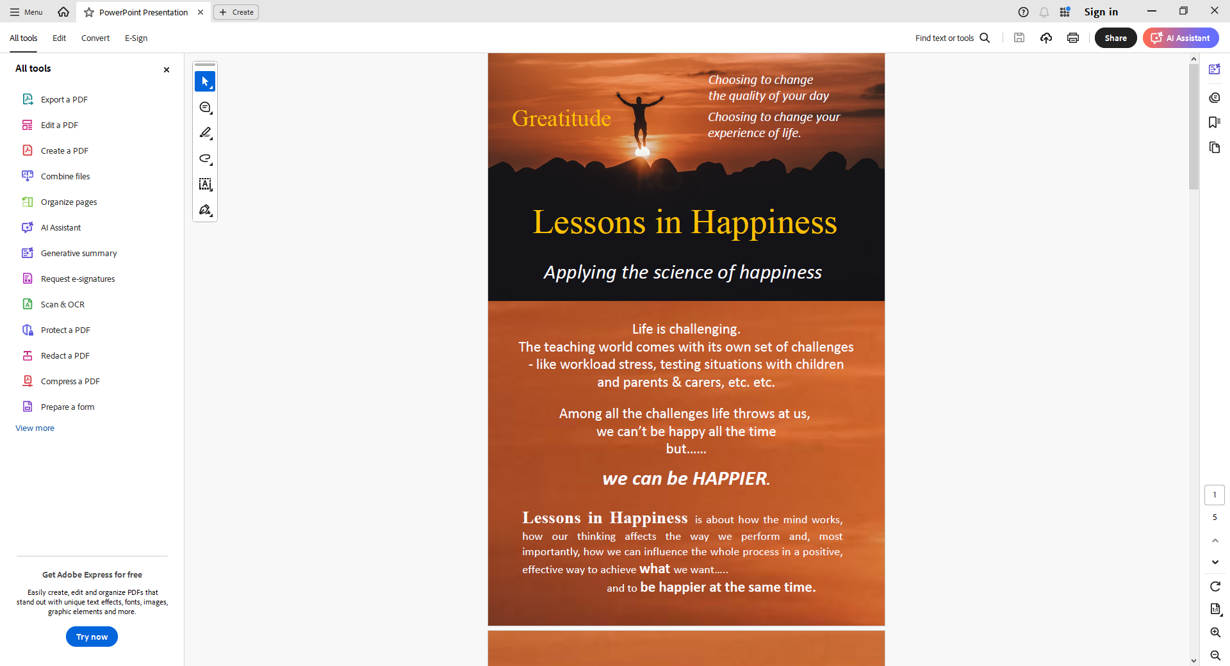

Lessons in Happiness (15/2/24) Feedback

Overall extremely positive feeback.
2 people provided some comments (see here).
1 person, circled in red, was a distinct negative outlier. They provided the following comments:
In response to Question 2 – ‘Nothing that I don’t already do’, as well as a general comment of ‘Sorry to be negative but I don’t feel I learned anything that wasn’t covered by just being a teacher in today’s world. 3 hours of listening with little engagment with audience – too much’
1 person, circled in blue, provided the following comments in response to Question 1 – ‘I have so enjoyed this afternoon and feel well equipped to try some ideas from your toolbox (now my toolbox) over the next few weeks. John was SUPERB to listen to. I feel hugely inspired’.

